INDEXU 7
Google Maps Integration

By Dody Rachmat W. (dodyrw@gmail.com)
August 27, 2011

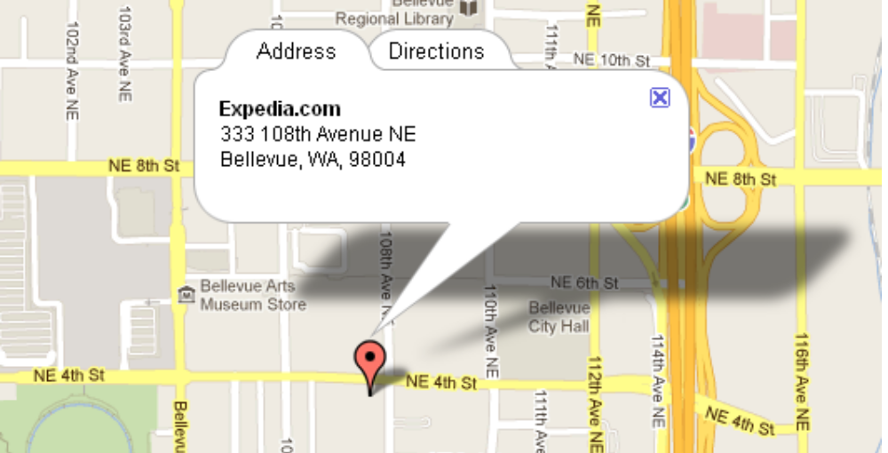
Indexu shows google maps on detail page. The information for google maps is gathered from listing’s detail :
- address
- city
- state
- zip
- country

In order to activate google maps integration, you need to get Google Maps API key. This API Key must be obtained for each website you have. To get the API Key, go to the following url:
http://code.google.com/apis/maps/signup.html

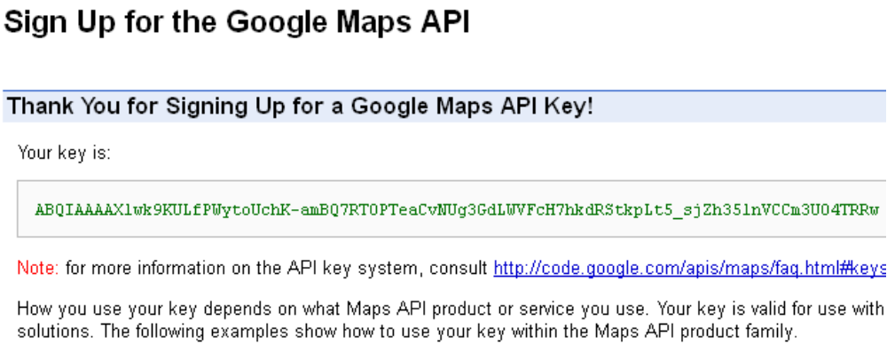
Enter the API Key in Indexu admin panel.
Admin Panel > 3rd Party > Google
